1.Command: whoami
      - Description: Displays the current user account.
      - Example: Running whoami in the terminal will show your username, like john_doe.


2 Command: ls
      - Description: Lists files and directories in the current directory.
Example: ls will display files and folders in your current directory, and ls -l provides detailed information

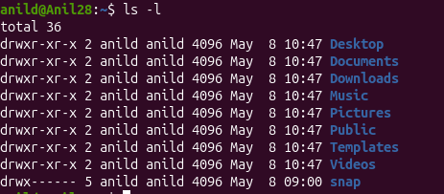

3.Command: ip a
● Description: Lists your IP address and network interfaces.
● Example: ip a show all network interfaces and their IP addresses.



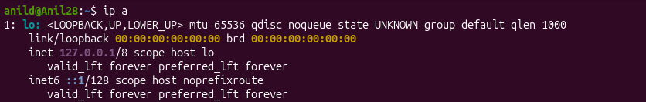
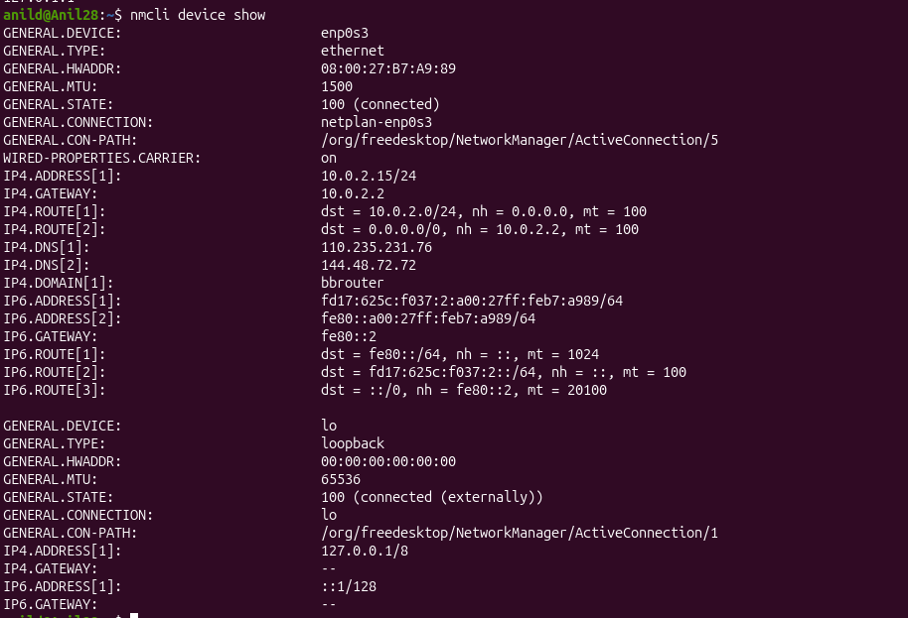

Command: cat
● Description: Reads the contents of text files.
● Example: cat myfile.txt will display the content of myfile.txt.

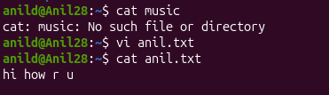

Command: passwd
● Description: Used to change the password of the user account.
● Example: Typing passwd and following the prompts will allow you to change your password.

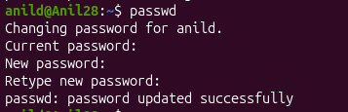

Command: touch
● Description: Creates empty files, mainly useful to test write ability.
● Example: touch newfile.txt creates an empty file named newfile.txt.

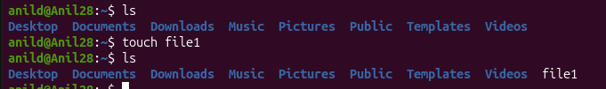

Command: pwd
● Description: Stands for Print Working Directory; shows which directory you are in.
● Example: Running pwd might return /home/john_doe.



Command: man
● Description: Accesses the system documentation for commands.
● Example: man ls will show the manual for the ls command.
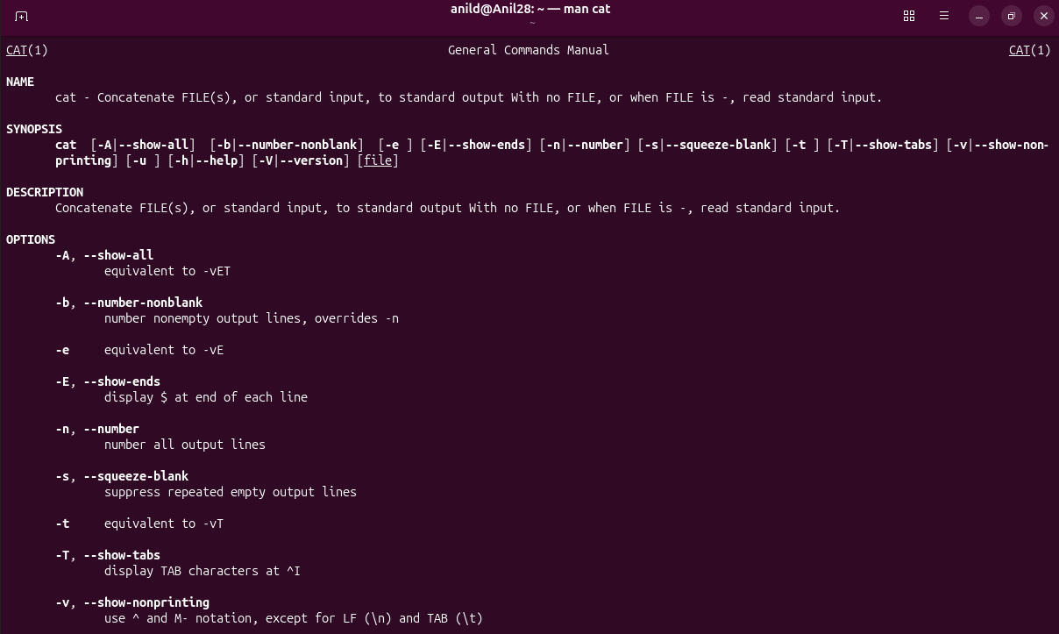

Command: apropos
● Description: Searches commands related to a specific task based on description
(equivalent to man -k).
It helps you find commands when you do not know the exact command name.
● Example: apropos "list files" might return commands related to listing files.

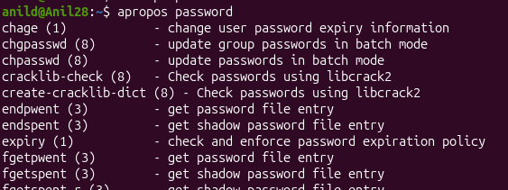

Command: pinfo
● Description: Provides additional information, similar to man.
● Example: pinfo ls gives detailed information about the ls command.

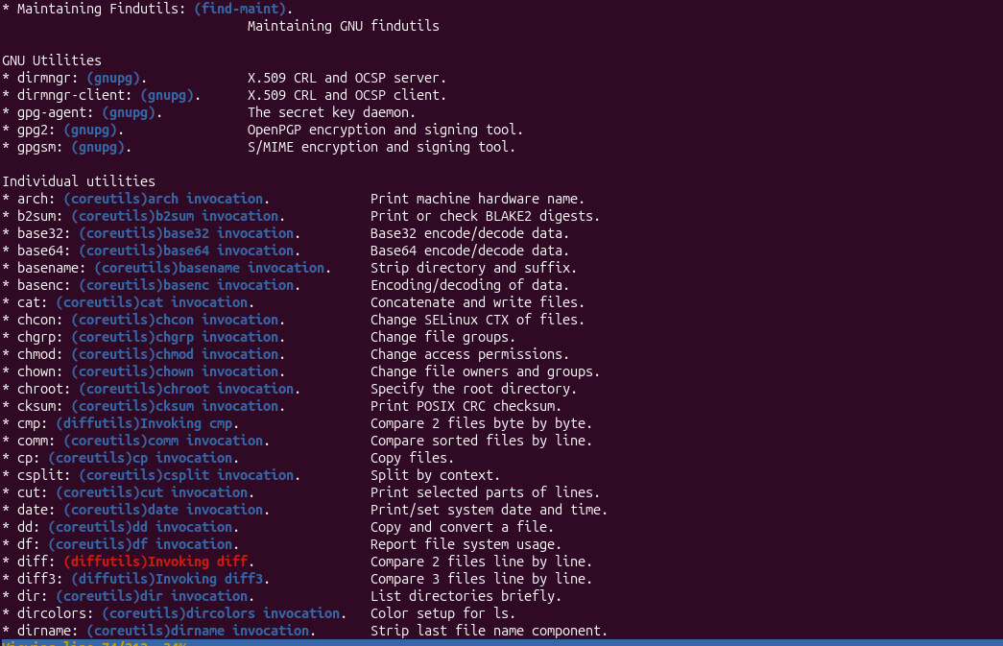

Command: tldr
● Description: Shows command line examples, a simplified version of man.
● Example: tldr passwd provides quick examples of how to use the passwd

It is useful when the man page feels too long or confusing.

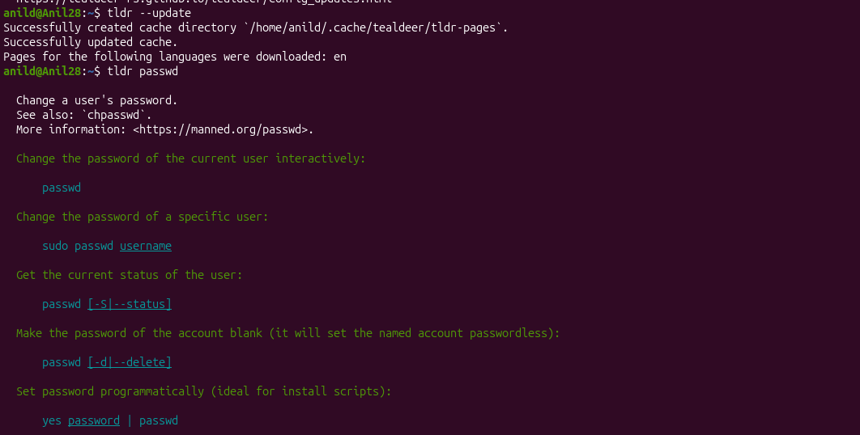

Essential File Management Tools Commands

Command: ls
● Example: ls /home/user/Documents
● Description: Lists files and directories within a specified path. This command is used to view the contents of directories.



Command: cp
● Example: cp source.txt destination.txt
● Description: Copies files from one location to another. This command is used to make duplicates of files
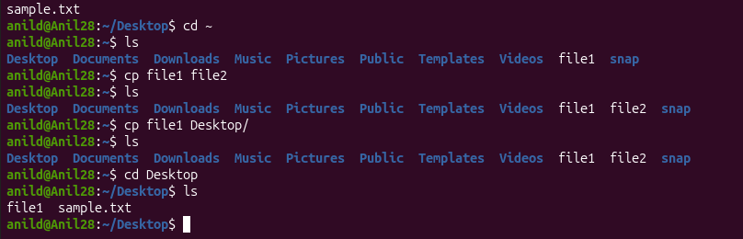

.
Command: mkdir
● Example: mkdir new_directory
● Description: Creates a new directory. This command is used when you need to make a new folder.

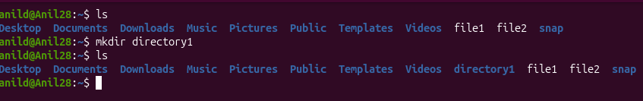

Command: rmdir
● Example: rmdir empty_directory
● Description: Removes a directory, but only if it's empty. This command is used for deleting empty folders.

Command: mv
● Example: mv oldname.txt newname.txt
● Description: Moves or renames files and directories. This command can change the location or the name of a file.

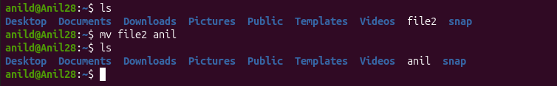

Command: rm
● Example: rm filename.txt
● Description: Removes files or directories. This command deletes files or
directories.
● Note: When combined with options -r (recursive) and -f (force), as in rm -rf directory_name, it becomes a powerful command that can delete directories and their contents without asking for confirmation.
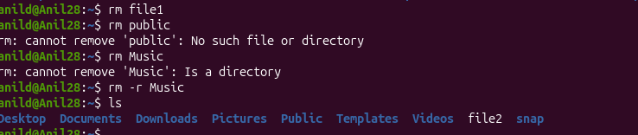

Advanced File Management Tools Commands

ln: Used for creating hard and symbolic links.
● Example: ln -s source_file symbolic_linkcreates a symbolic link to source_file.
● Description: Links a file or directory to another location.
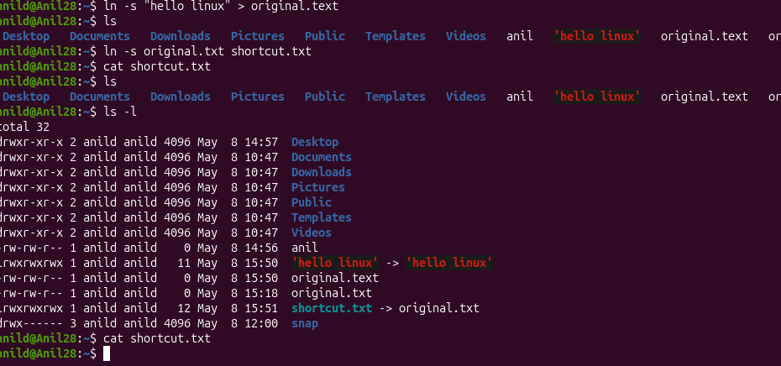

Hard link = another name for the same file data

find: A utility to find files based on various properties.
● Example: find /home -name "*.txt"searches for text files in the /home directory.
● Description: Searches for files and directories in a given path.


locate: Used for quickly searching the database of system's contents.
● Example: locate filename finds the location of filename.
● Description: Fast file searching, requires running updatedb for an updated database.
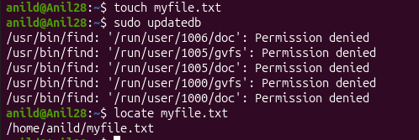

which: Finds the location of executables in the PATH.
● Example: which python shows the path of the Python executable.
● Description: Useful for finding executable files in system's PATH.


tar: Archives multiple files into a single file.
● Example: tar -cvf archive.tar /foldercreates an archive of a folder.
● Description: Combines multiple files into a tarball.
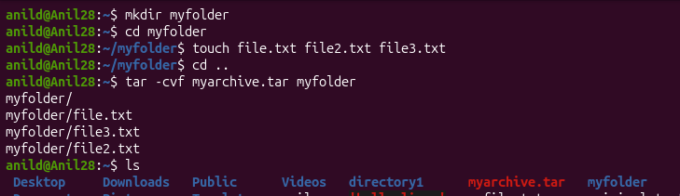

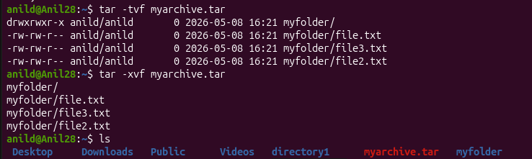

gzip: Compresses files.
● Example: gzip file.txt compresses file.txt.
● Description: Reduces the size of files using compression.
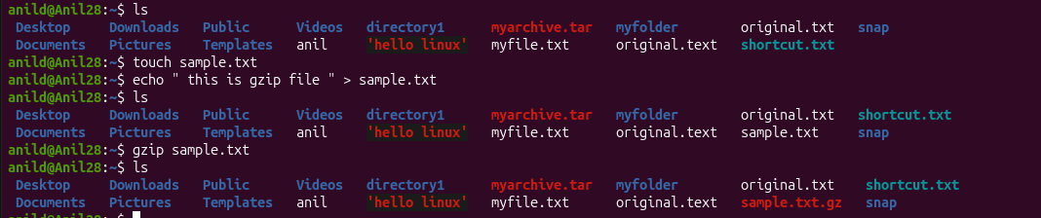

bzip2: A file compression utility.
● Example: bzip2 file.txt compresses file.txt.
● Description: Offers better compression ratios than gzip at the cost of speed.
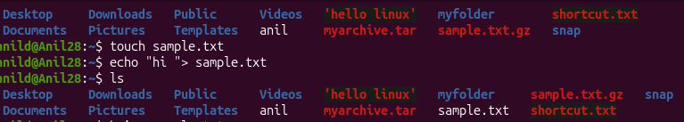

xz: High compression utility.
● Example: xz file.txt compresses file.txt.
● Description: Provides the best compression ratio.
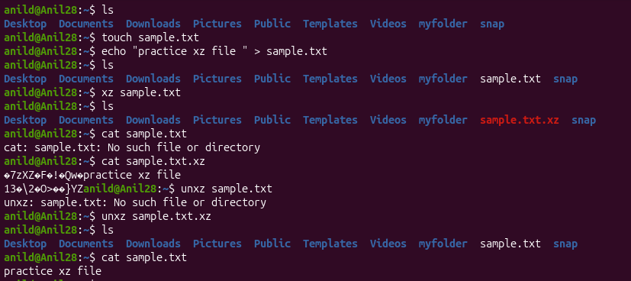

zip: Used for packaging and compressing (archiving) files.
● Example: zip archive.zip file1 file2 creates an archive with file1 and file2.
● Description: Commonly used for creating .zip files.
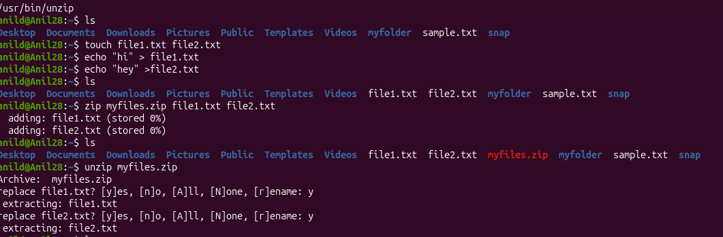

file: Determines the type of a file.
● Example: file image.jpg displays the type of image.jpg.
● Description: Useful for identifying file formats.
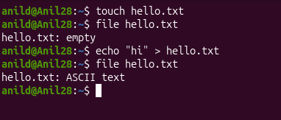

mount: Attaches a filesystem to a specified directory.
● Example: mount /dev/sdb1 /mnt mounts the device sdb1 to /mnt.
● Description: Used to access filesystems on different storage devices.
This is usually used for USB drives or extra disks.

df: Displays disk space usage of all mounted filesystems.
● Example: df -h shows disk space in human-readable format.
● Description: Useful for monitoring disk space usage.
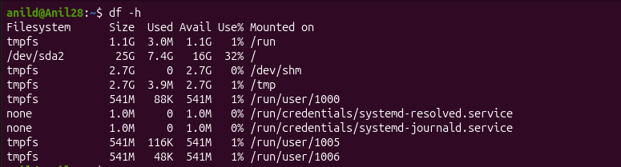

findmnt: Lists all mounted filesystems.
● Example: findmnt -t ext4 lists all ext4 type mounts.
● Description: Displays a tree-like structure of mounts.

-t means type
ext4 is filesystem type

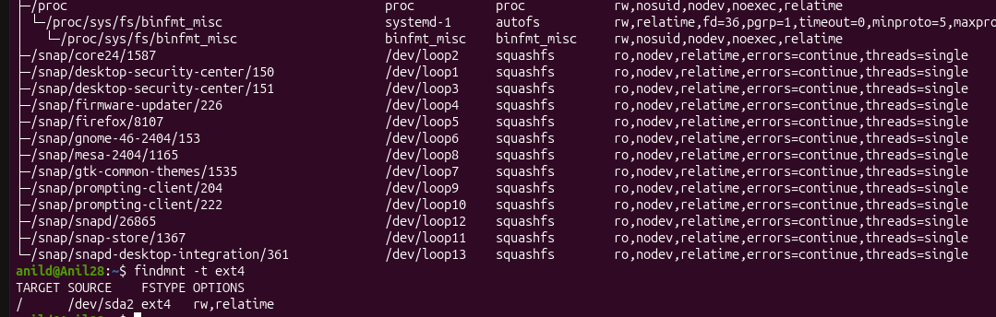

lsblk: Lists information about block devices.
● Example: lsblk lists all block devices.
● Description: Useful for identifying storage devices and their partitions.

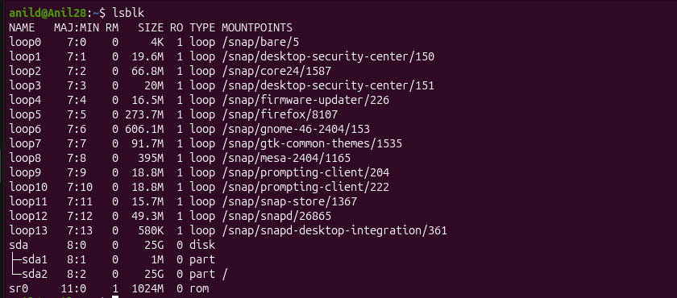

Working with Text Files Commands

nano
● Description: A user-friendly text editor.
● Example: nano filename.txt - Opens filename.txt in nano editor.

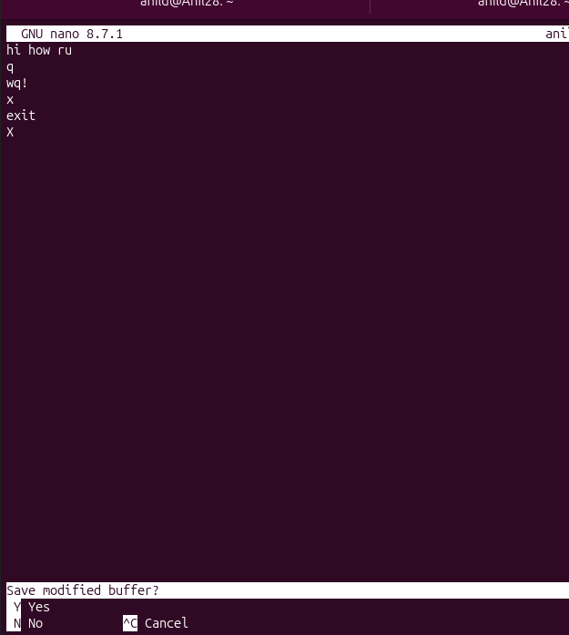

vimtutor
● Description: A tutorial program for learning VIM, an advanced text editor.
● Example: vimtutor - Starts the VIM tutorial.
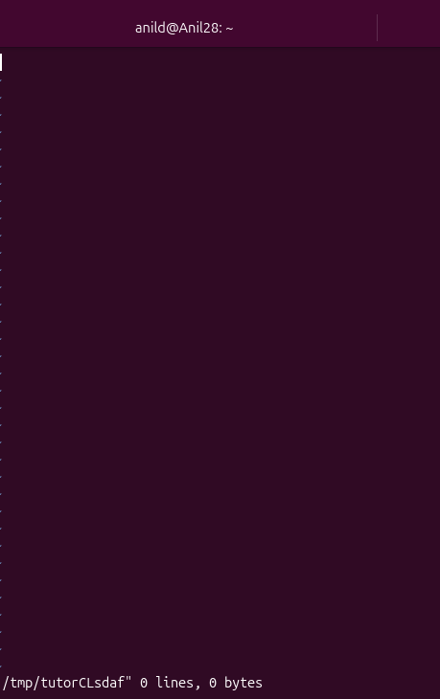

vi
● Description: The original text editor, with basic features.
● Example: vi filename.txt - Opens filename.txt in VI editor.
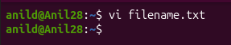
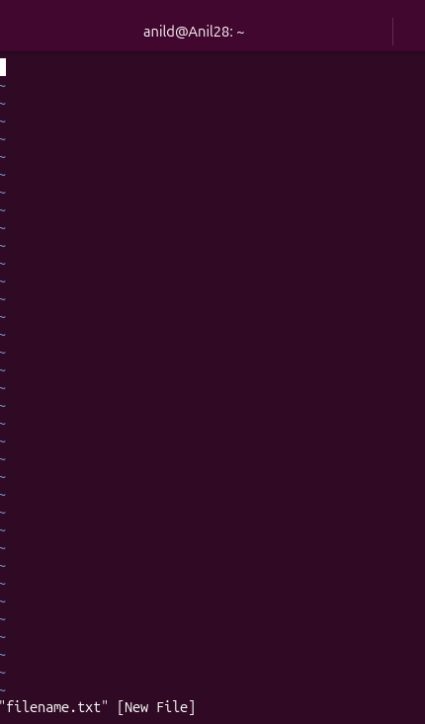

vim
● Description: An improved version of VI with more features.
● Example: vim filename.txt - Opens filename.txt in VIM editor.
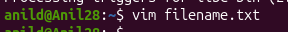
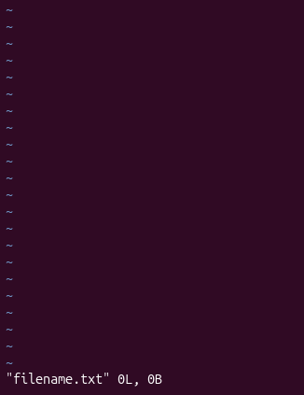

more
● Description: A pager to view the contents of text files, one screen at a time.
● Example: more filename.txt - Views the content of filename.txt.
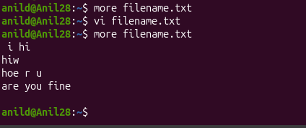

less
● Description: Similar to more, but provides more control over viewing text files.
● Example: less filename.txt - Opens filename.txt for viewing with navigation
options.
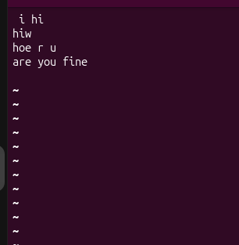

head
● Description: Displays the first few lines of a text file.
● Example: head filename.txt - Shows the top lines of filename.txt.

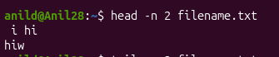

tail
● Description: Displays the last few lines of a text file.
● Example: tail filename.txt - Shows the last lines of filename.txt.
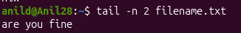

cat
● Description: Concatenates and displays the entire content of text files.
● Example: cat filename.txt - Displays the full content of filename.txt.
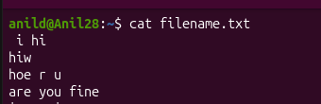

cat -A
● Description: Similar to cat, but also displays special characters.
● Example: cat -A filename.txt - Shows the content of filename.txt, including special
characters.
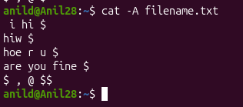

tac
● Description: Prints the contents of a text file in reverse order.
● Example: tac filename.txt - Displays filename.txt content backwards.
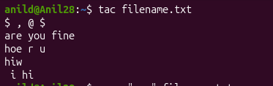

grep
● Description: Searches for text in files or command output.
● Example: grep 'pattern' filename.txt- Searches for 'pattern' in filename.txt.
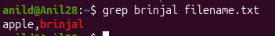

Advanced Text File Processing Commands

grep:
● Command: "grep"
● Example: "grep 'pattern' file.txt"
● Description: Filters text in files by searching for specific patterns.
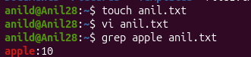

To ignore uppercase/lowercase:
grep -i 'apple' file.txt

awk:
● Command: "awk"
● Example: "awk '/pattern/ {print}' file.txt"
● Description: Filters and processes text, with additional features for text manipulation.
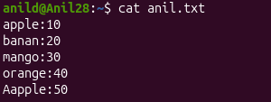
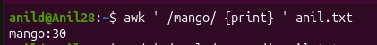

awk -F':' '{print $1}' file.txt
Here : is used as a separator, and $1 means print the first column.

sed:
● Command: "sed"
● Example: "sed 's/old/new/' file.txt"
● Description: A stream editor used for modifying text files directly from the
command line.

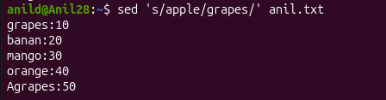

To actually update the file: (does not change the original file actually )
sed -i 's/apple/grapes/' file.txt

tr:
● Command: "tr"
● Example: "tr '[:lower:]' '[:upper:]' < file.txt"
● Description: Translates or deletes characters from input text
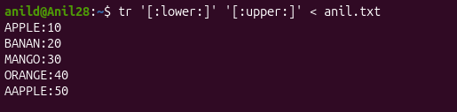

To delete a character, example delete ::
tr -d ':' < file.txt

.
cut:
● Command: "cut"
● Example: "cut -d':' -f1 file.txt"
● Description: Extracts sections from each line of files, such as columns from a table.
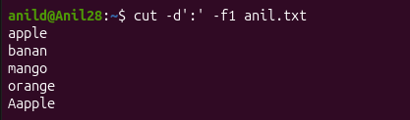

To print the second column:
-d':' means the separator is :
cut -d':' -f2 file.txt

sort:
● Command: "sort"
● Example: "sort file.txt"
● Description: Sorts text files in alphabetical or numerical order, as specified.


